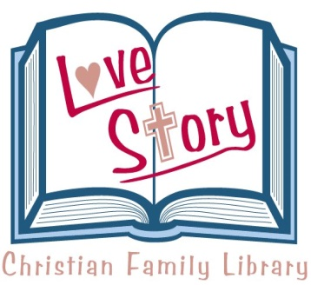
HOW YOUR CHILDREN’S PERFORMANCE
IS RELATED TO THEIR VISION

Tuesday, June 25, 2019
6:30 p.m.

3792 Broadway
Buffalo, NY 14227

Restoring hope and vision to children and adults is the focal point of all we do at Vision Development of WNY. For more than 40 years Dr. Dick O’Connor has been restoring vision to people who experience learning disabilities, developmental delays, behavioral issues, head/brain injuries, and strokes - helping them to realize a better future.

Dr. O’Connor specializes in Behavioral Optometry. He evaluates for all the visual skills that are required for the eyes and brain to work together in order to effectively intake, process and respond to the visual information entering the eyes. This is very specific testing which is not part of an annual eye exam.

For patients that require intervention, we offer different programs of care based on the diagnosis and needs of the patient. We utilize Phototherapy (light therapy) which focuses on regulating and balancing the nervous system, along with Vision Therapy which develops and trains the brain/eye connection through specialized equipment and techniques.

Vision Development of WNY is a faith-based company, which honors God and diligently pursues our patient’s best interests.

We look forward to meeting you!

We have limited seating! Please RSVP by Friday, June 21, 2019.
Phone 716-681-4896 or email Joanne@cluonline.com

